Project Design Phase-II
Technology Stack (Architecture & Stack)

Date | 19 July 2026
Team ID
Project Name | SHOPEZ: E-Commerce Application
Maximum Marks | 4 Marks

Technical Architecture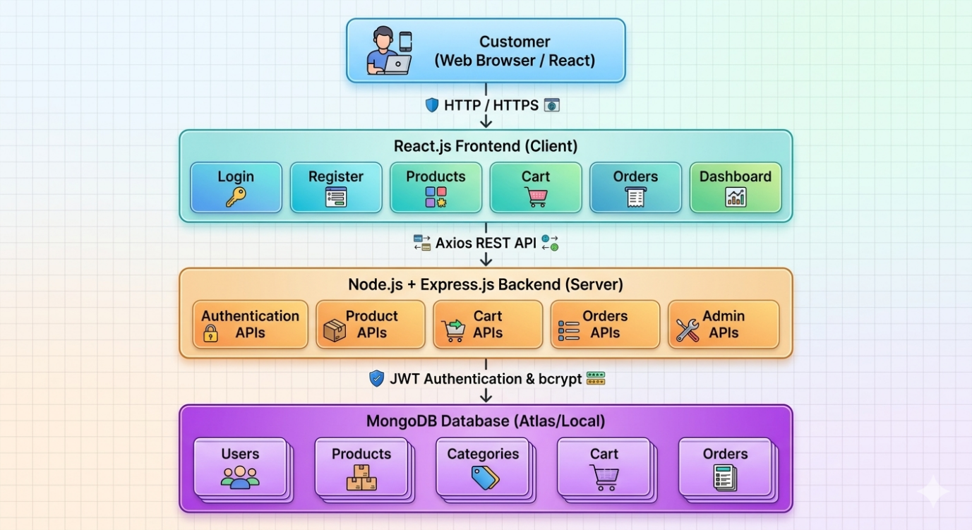
Table-1: Components & Technologies
S.No | Component | Description | Technology
1 | User Interface | Customer and Admin Web Interface | React.js, HTML5, CSS3, Bootstrap, JavaScript
2 | Application Logic-1 | User Authentication & Authorization | Node.js, Express.js, JWT, bcrypt
3 | Application Logic-2 | Product, Cart & Order Management | Node.js, Express.js
4 | Application Logic-3 | REST API Communication | Axios, Express REST APIs
5 | Database | Stores users, products, categories, carts and orders | MongoDB
6 | Cloud Database | Cloud-hosted database (optional) | MongoDB Atlas
7 | File Storage | Product Images | Local Storage / Cloudinary (optional)
8 | External API-1 | Payment Processing | Razorpay API / Stripe API (optional)
9 | External API-2 | Email Notifications | Nodemailer / Gmail SMTP
10 | Machine Learning Model | AI Product Recommendation (Future Enhancement) | Recommendation Algorithm
11 | Infrastructure (Server/Cloud) | Local Development / Cloud Deployment | Node.js Server, Render, Vercel, MongoDB Atlas

Table-2: Application Characteristics
S.No | Characteristic | Description | Technology
1 | Open-Source Frameworks | Frameworks used to develop the application | React.js, Express.js, Node.js, Bootstrap
2 | Security Implementations | Secure authentication, password encryption, protected APIs | JWT, bcrypt, HTTPS, CORS
3 | Scalable Architecture | Three-tier architecture supporting future expansion | MERN Stack (Client–Server–Database)
4 | Availability | Application accessible anytime through web deployment | MongoDB Atlas, Render/Vercel
5 | Performance | Fast page loading, optimized API responses, efficient database queries | React.js, Axios, MongoDB Indexing

